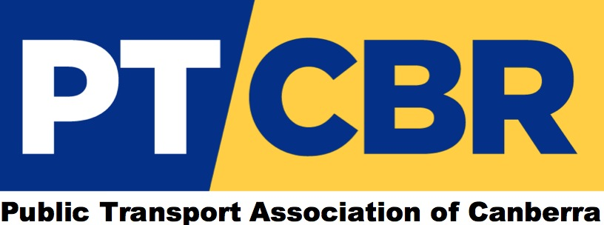

FINANCIAL STATEMENT FY 2022
The Association Incorporation Act 1991 requires a statement of accounts that give a true and fair account of:
- The income and expenditure of the Association during the last financial year,
- The assets and liabilities at the end of the financial year.
Income
Membership fees, and the interest from a bank account comprise the income.
$1,010 was received from members in FY 2022, including membership fees and donations. This was $560 more than contributed by members in the previous financial year.
Expenditure
Each expenditure item was supported by an invoice, or a receipt, or a bank statement in the case of a direct debit. The expenditure was in accordance with the Council’s objectives as listed in the Constitution dated Dec 2016.
Expenditure totalled $870.59 in FY 2022, which was $189.14 more than expenditure in the previous year. Public liability insurance ($537.95) continued to be the largest expense, followed by website management software ($332.64).
Assets
The PTCBR does not hold any assets other than cash in its bank account.
Liabilities
There are no liabilities to be carried over.

Mark Loney
Treasurer

Enclosures
Income and Expenditure 2021-22
Balance Sheet for Year Ending 30 June 2022

PUBLIC TRANSPORT ASSOCIATION OF CANBERRA
INCOME AND EXPENDITURE 2021-22

Funds Available 01 July 2021 $239.63
INCOME
Member Contributions $1,010.00
Bank interest $0.03
+ $1,010.03
EXPENDITURE
Public Liability Insurance $537.95
Website Management Software $332.64
- $870.59
Funds Carried Forward 30 June 2022 $379.07

BALANCE SHEET FOR YEAR ENDING 30 June 2022

ASSETS
Beyond Bank Account $379.07
Total Assets $379.07

LIABILITIES NIL

NET ASSETS $379.07

M. Loney
Mark Loney
Treasurer
21 October 2022

